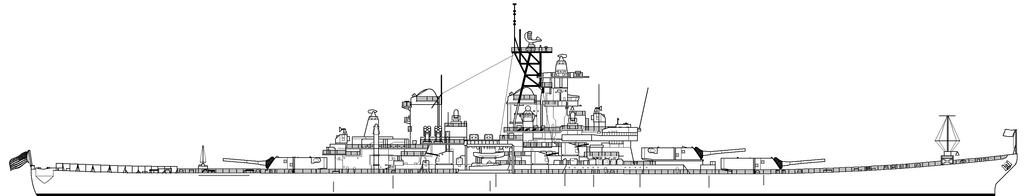

Ceremony Information:
Name:
Command Name:
Rank/Rate:
Branch of Service: |  | Active Duty ☐ | Reserves ☐
Ceremony or event Type:  (select one) | ☐ Re-enlistment (30 minutes)  ☐ Promotion/Commissioning (30 minutes)  ☐ Retirement (2 hours)  ☐ Change of Command (2 hours)  ☐ Change of Responsibility (1 hour)  ☐ Assumption of Responsibility (1 hour)  ☐ Flag raising (Include rank/rate name as you would like it to appear on the certificate): Click here to enter text.  ☐ Tour (Specify): Click here to enter text.  ☐ Other (Specify): Click here to enter text.
Estimated # of Guests:

Desired Date: |  | Desired Time:
- 1st Choice |  | - 1st Choice
- 2nd Choice |  | - 2nd Choice
Primary Point of Contact: (Ceremony Coordinator)
Name & Rank:
Work Phone:
Mobile:
Email:
Alternate Point of Contact:
Name & Rank:
Work Phone:
Mobile:
Email:

If you have any questions, please email military@ussmissouri.org
or contact us by telephone at (808) 455-1600 ext. 225 or 258

We will respond to all requests within five business days

